**Wireshark for Beginners: Capture Packets**

**Task 1**

**Install and set up Wireshark on Ubuntu:**

●To get the latest stable version of Wireshark on Ubuntu Linux, use the add-apt-repository command: ***sudo add-apt-repository ppa:wireshark-dev/stable***

●Wireshark should not be run as superuser for security reasons.

●The user can be added to the Wireshark group to add packet capture capabilities: ***sudo usermod -aG wireshark $USER***

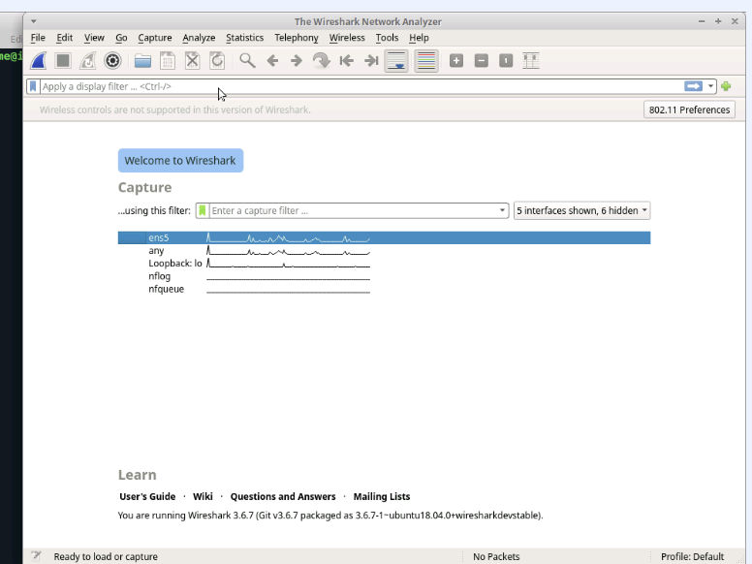

**Task 2**

**Start a packet capture on an ethernet port and save it to file**:

●The wired interface includes the ethernet packet capture, which begins with ‘en’ in Wireshark.

●The Wireshark app includes controls to start packet capture, stop capture, save the packets to a file, and load the capture file.

●A capture can only be saved once the capture has stopped.

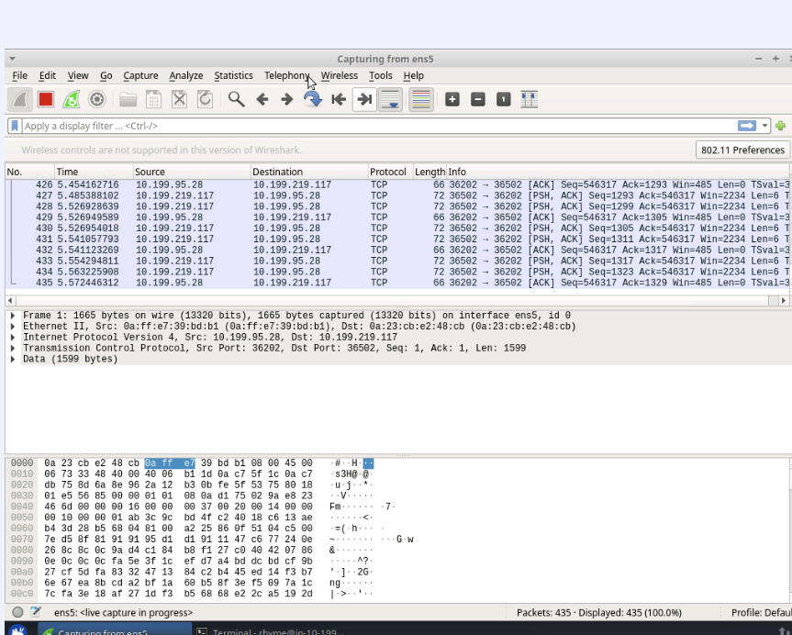

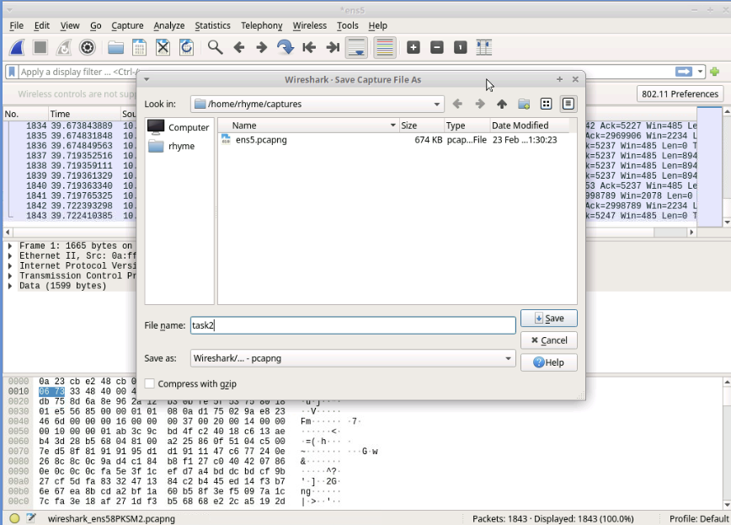

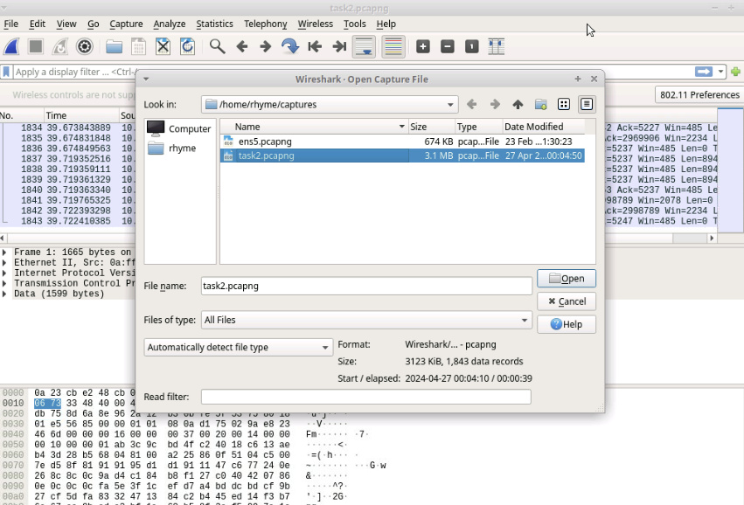

**Task 3**

**Use a display filter to detect HTTPS packets:**

●To display certain packets in an existing packet capture, use a display filter.

●To display only HTTPS traffic, use a filter on TCP port 443: ***tcp.port == 443***

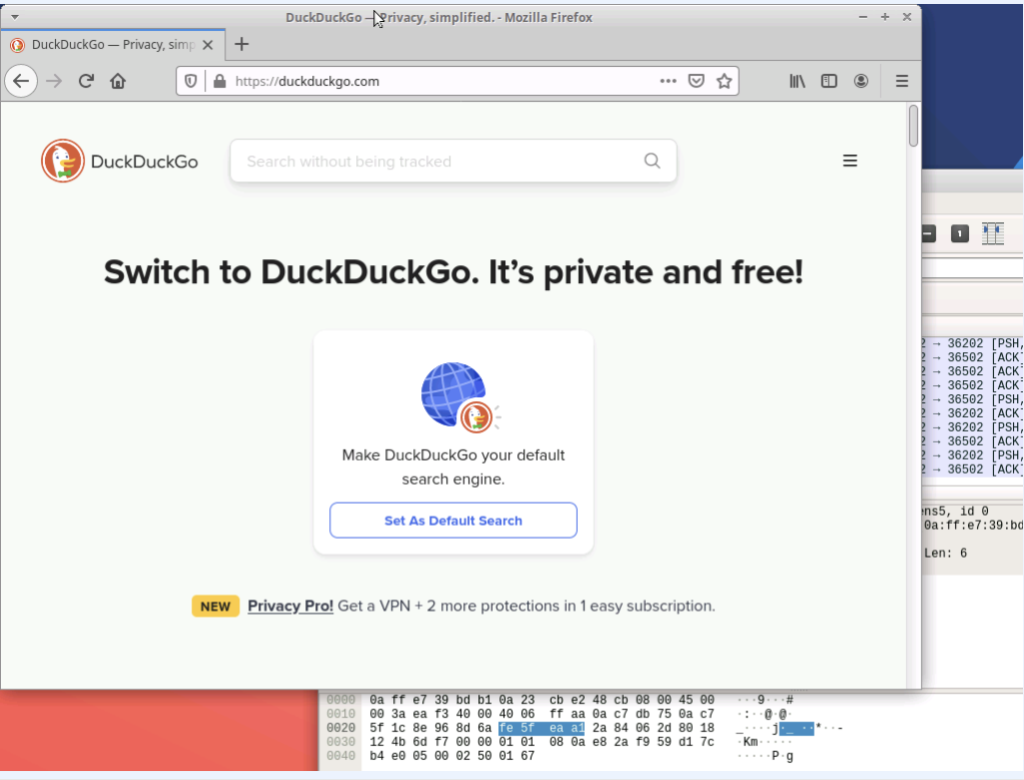

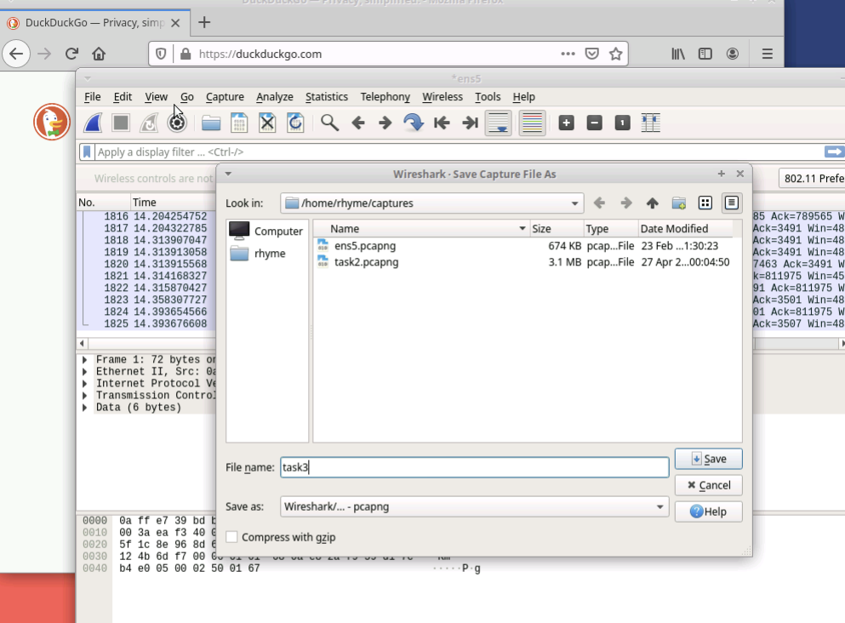

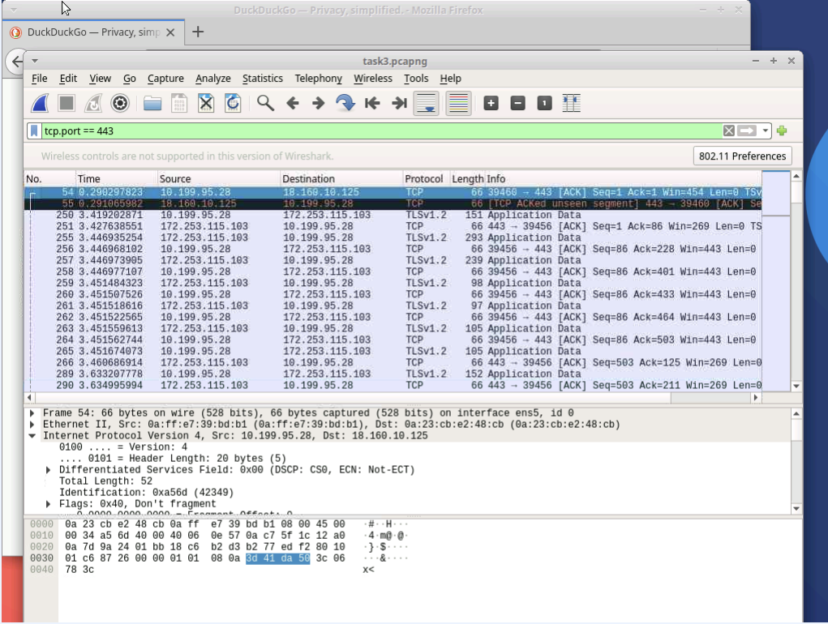

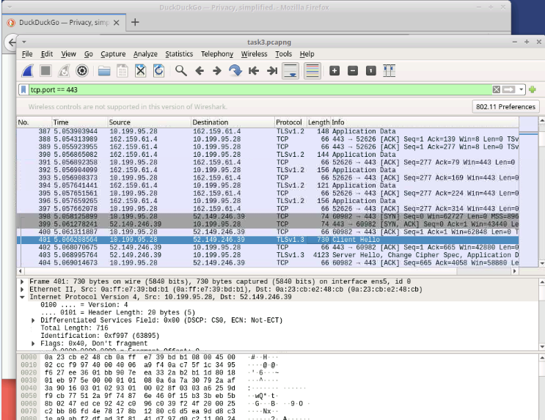

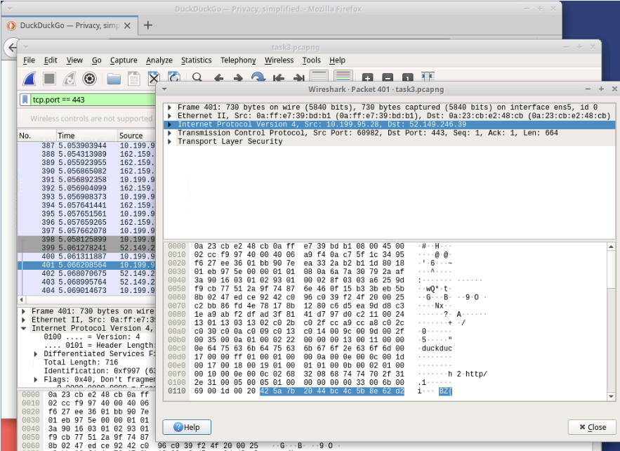

**Task 4**

**Visit a web page and detect its IP address using a display filter:**

●A TLS handshake display filter may be used to detect a website visit in a packet list: tls.handshake.type ==1

●The IP address is used in a filter to obtain packet information for a particular website: ip.addr == 142.251.163.105

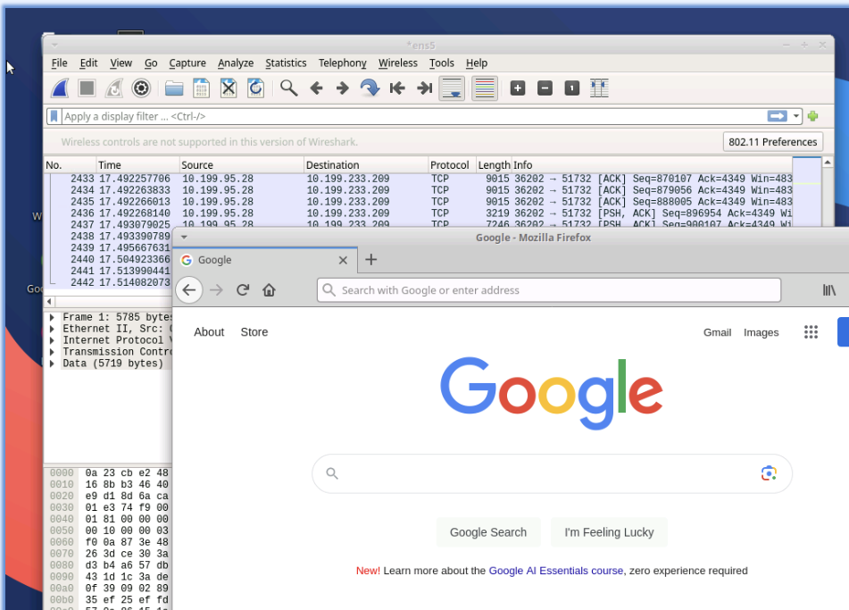

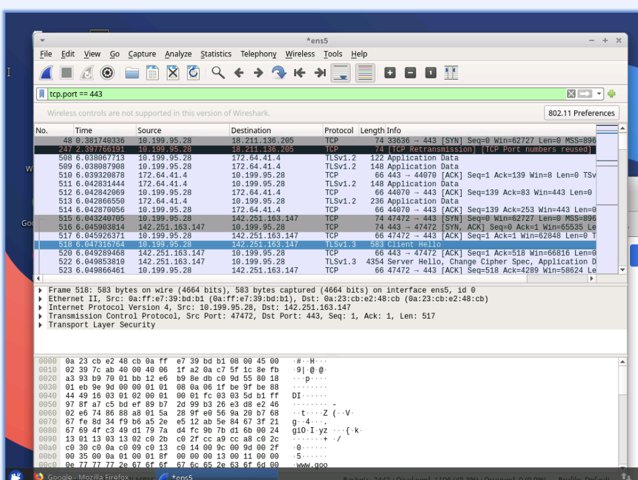

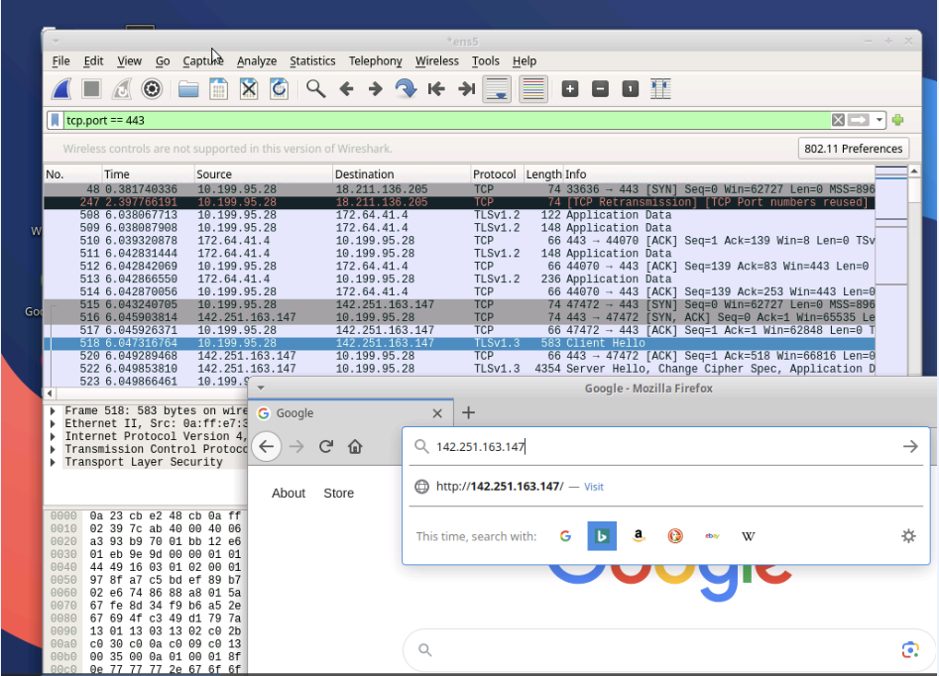

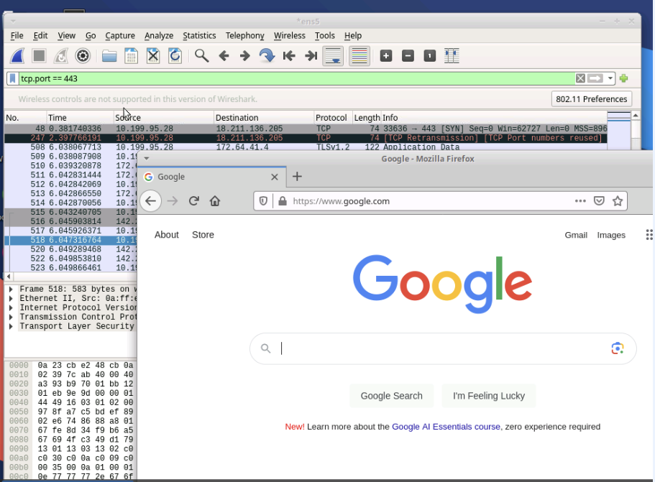

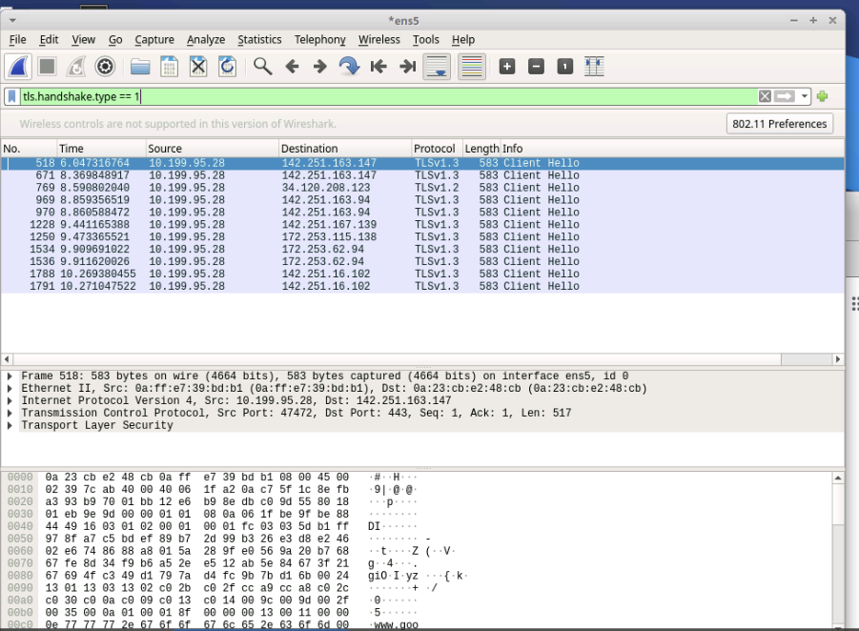

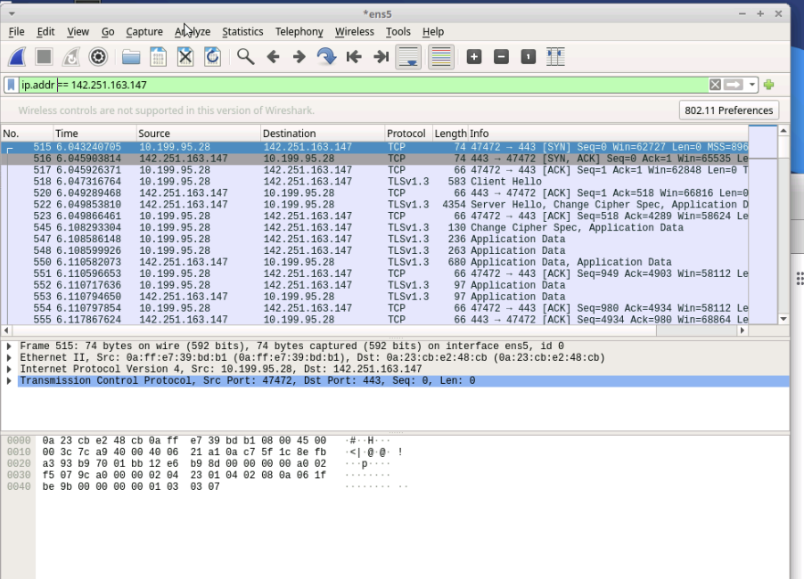

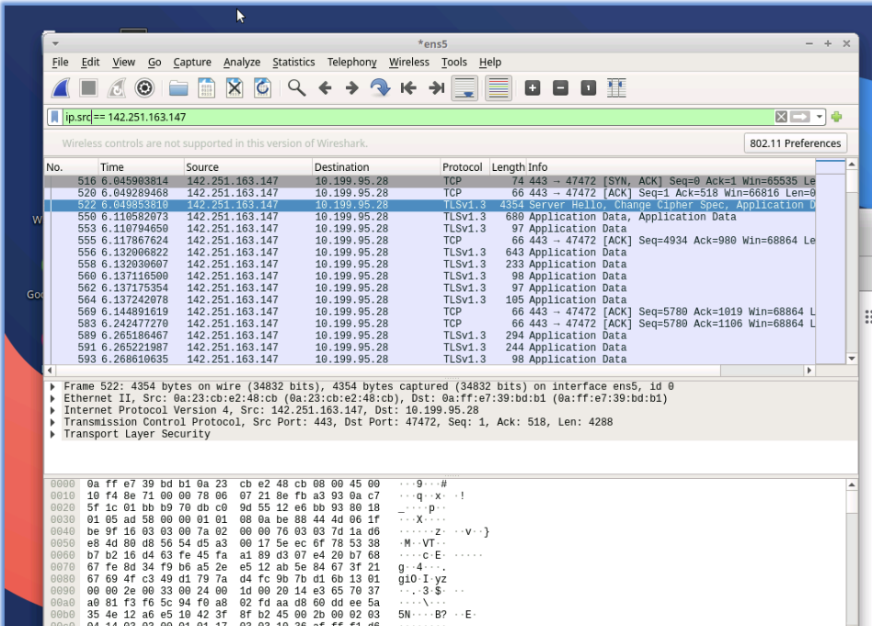

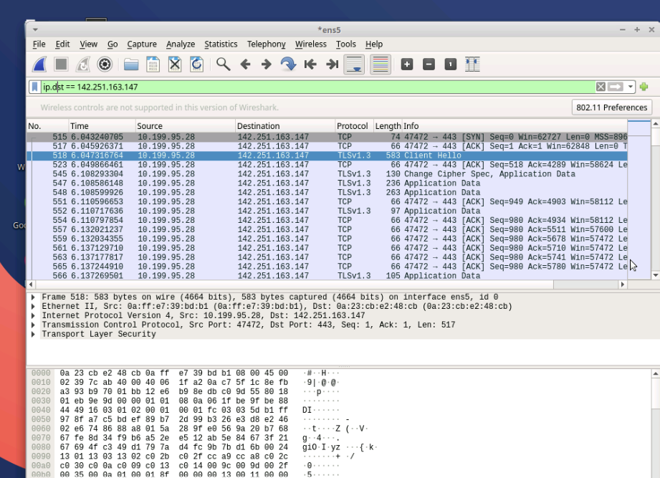

**Task 5**

**Locate all HTTPS packets from a capture not containing a certain IP address:**

●A Conditional statement may be used to include and eliminate packets from a Wireshark capture: !(ip.addr == 8.43.85.97) and tcp.port == 443

●A compound conditional should include parentheses to avoid order of execution errors: !(ip.addr == 8.43.85.97) and (tcp.port == 80 or tcp.port == 443)



